

Longstone Nursery Class
2026-2027
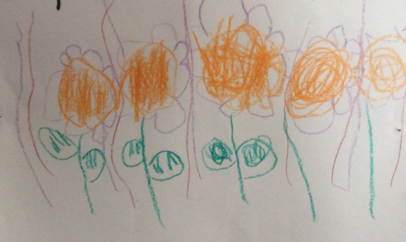

Longstone Nursery Class
Welcome to Longstone Primary School Nursery Class.
This booklet contains a range of information about our nursery which we hope will be of interest to you and your child. We are committed to working closely with our families as equal partners in your child’s learning and development. Family involvement in the support of this is an integral part of nursery life.
We hope that both you and your child will enjoy your time with us and we look forward to working together to expand your child’s learning experiences.
Currently, Longstone Nursery operates during term time only and has 55 places for children aged between 2 and 5 years old. Children are currently offered 1140 hours full-time places as outlined below.
Nursery Hours
Monday-Thursday | Friday
0815-1445 | 0815-1215

Nursery Staff
Head of Centre – Sonia Masson
Early Years Officer- Mrs Fiona Scott
Early years Officer - Miss Katie Gilmore
Early Years Officer / EYP - Mrs Siobhan Wells
Early Years Practitioner - Miss Megan Anderson
Early Years Practitioner - Mrs Gill MacKenzie
Early Years Practitioner – Mrs Tracey Porterfield
Early Years Practitioner - Mrs Rachel Murdoch
Early Years Practitioner– Mrs Kiran Waheed
Early Year Assistant- Mrs Irene Paul
Domestic Assistant – Mrs Meena Rathinam
Senior Leadership Team (SLT)
Head Teacher - Mrs Sonia Masson
Deputy Head - Mrs Joy Goodlet
Term Dates 2026/27
Term dates for the coming years can be found at
https//www.edinburgh.gov.uk/schools/term-dates
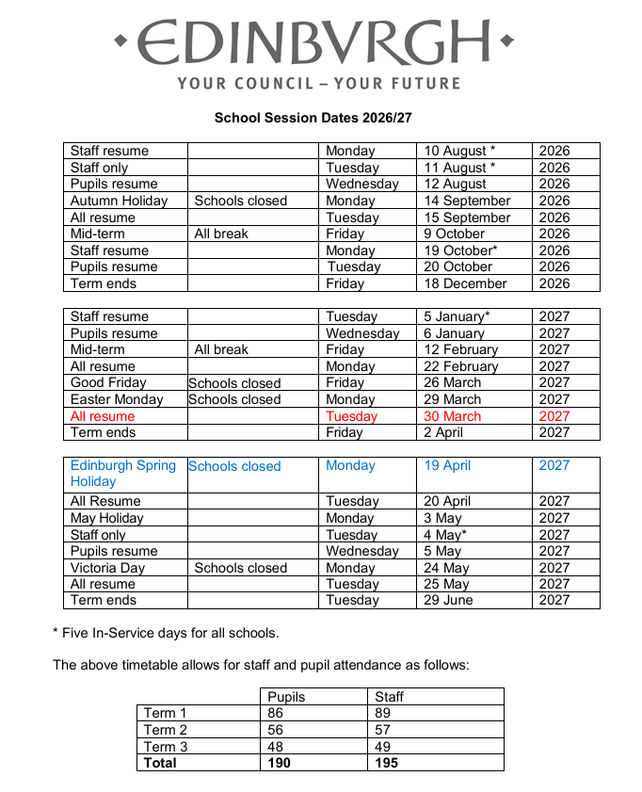

Nursery Curriculum

In order to offer and plan for rich learning experiences and a high standard of provision and care, we use the Frameworks, Realising the Ambition, as well as the National Curriculum for Excellence (CfE) at Early Level for our older children (4-5 year olds) and Birth to Three curriculum for our 2-3 year olds.

Underpinning all our work and woven through all our guidance documents are children’s rights as specified in UNCRC (United Nations Convention for the Rights of the Child) and ratified by the UK in 1989. The Getting it Right for Every Child Framework identifies 8 Wellbeing Indicators as (SHANARRI – Safe, Healthy, Active, Nurtured, Achieving, Responsible, Respectful and Included) aligned to the rights specified by the UNCRC to enable all children and young people to grow, develop and reach their full potential.

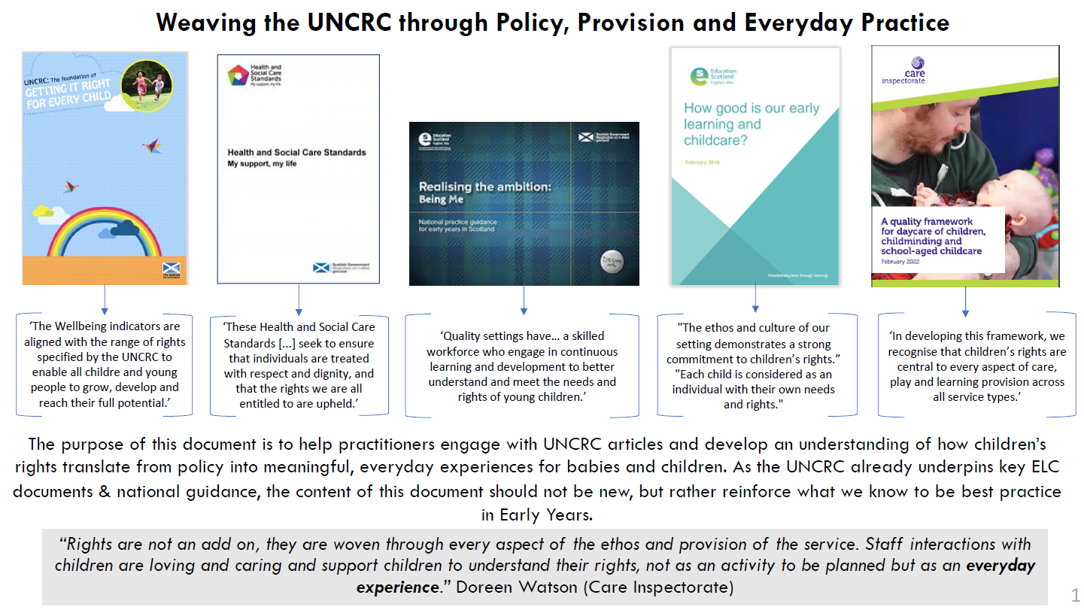

Care Inspectorate
As with all establishments caring for children up to the age of 16, Longstone Nursery Class is monitored by the Care Inspectorate. Our most recent inspection report (February 2019) is available on the Care Inspectorate website.
https://www.careinspectorate.com/
The nursery had a joint School and Nursery HMIe Inspection in March 2021. You can download the inspection report here;
https://education.gov.scot/education-scotland/inspection-reports/reports-page/?id=3542
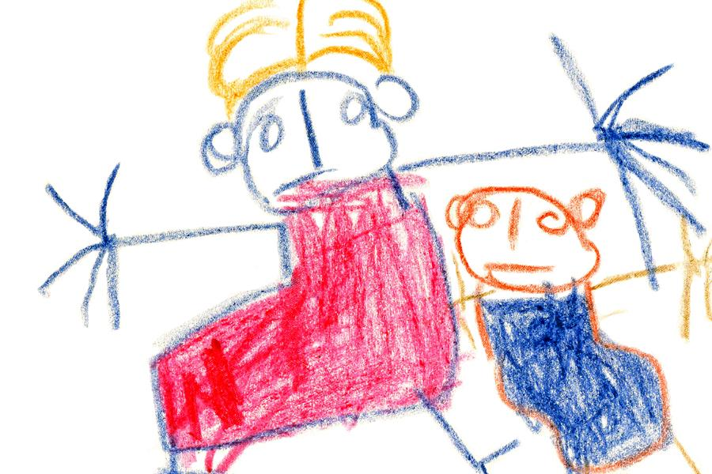

Starting Nursery
Settling in / drop off and pick up protocols
Starting at nursery is a major stepping stone and very exciting time for you and your child and the staff at Longstone Nursery aim to make the settling in process as positive and smooth a transition as possible. Occasionally, a child may feel shy or uneasy in a new environment and for the first few days we recommend shorter stays with a familiar adult until your child is settled.
On arrival you will be welcomed by a member of staff and meet your child’s key worker who will support you through the settling in period. Each child responds differently to starting at nursery and so the process will be tailored to their needs.
Your child’s safety is paramount while in our care. You will have had to provide emergency contact details when you applied for your nursery place and when you complete your Child’s Personal Plan during the settling process. It is extremely important that you make staff aware of changes to your Emergency Contact Information. In addition, we ask you to specify anyone other than you, who you permit to drop off or pick up your child at any point from nursery. We adhere strictly to the information given about adults who can do this and will not let your child go with anyone other than those specified unless your permission is gained.
To ensure we have as much important information about your child including their likes, dislikes or any other needs, medical or otherwise, we ask you to complete a form containing information which will form the basis of a ‘Child’s Personal Plan’. This will allow us to ensure we are as familiar with all that your child may need when beginning at nursery. If there is anything you wish to discuss about the information you give us, we will provide an opportunity to come in to discuss and if there is any information we need to follow up with you on we will do this in the first few days and weeks that your child is with us.

The Nursery Building

In the nursery itself we have two playrooms, The Butterfly Room and The Ladybird Room. These are at either end of the building with a cloakroom and reception foyer between them. The rooms and cloakroom have access to our lovely garden. Children in both rooms have opportunities to move freely between playrooms and the garden area. The Children are encouraged to explore both the playroom and garden area and to develop their independence and decision making from early on.

What to provide for your child at nursery

Please ensure your child comes to nursery wearing clothes that are comfortable and suitable for messy play. We aim to encourage children’s independence and ask you to consider shoes that are easy to slip on and off. As we are in Scotland, there are very few days where it is not necessary to have a warm jacket and suitable footwear for the outdoors. Wellies are advisable and can be stored in the nursery if necessary.
On sunny days, a sun hat should be supplied, and sun cream applied at home. We would advise that you purchase long lasting, single application sun cream, however, if you provide the nursery with sun-cream for your child on sunny days, we can ensure that this is re-applied.
Please ensure that all clothing and shoes are labelled clearly with your child’s name.
Please provide a spare set of clothes for changing if necessary. We do not insist on indoor shoes as the children move between indoors and outdoors, but you can provide these if you wish.
A school nursery polo shirt and sweatshirt are available to order if you wish. Please contact the office for details.

Snacks and Lunches
Snack is provided daily at nursery and children receive milk or water to drink. Following Early Years National Guidance, we provide healthy and tasty snack options such as fruit/vegetables, breadsticks, wraps and oatcakes.
Children in Nursery – P5 get the universal Free School Meal. This comprises of a hot school meal Monday-Thursday and includes a vegetarian option daily. On Friday the children are provided with a sandwich/roll fruit/yogurt and water to take home.
Within your welcome pack is a leaflet containing information about our online payment service, ParentPay. You will be given an activation letter very soon after your child starts at nursery. This will enable you to set up an account and login, if your child is new to the school. If you are already a parent with children on ParentPay, you can add additional children to your account. A copy of the school menu is available on request and is displayed at the entrances to our building.
During settling in you will have opportunity to inform us and discuss any special dietary requirements or allergies your child may have.

Attendance and Absence

If your child is unwell, please keep them at home, call the school office or leave a message on the answering machine to make us aware of child’s absence and why they will not be at nursey. If your child has vomited or had Diarrhoea since being in nursery, please keep them at home until they have been free of symptoms for a period of 48 hours.
To prevent the spread of infectious disease, please advise staff if your child has an infectious condition. We can then make our families aware of this in order to protect the wider community. We follow Health Protection Scotland (NHS) Infection Prevention and Control in Childcare Settings (May, 2018). guidelines on infectious diseases.

Medication
f your child requires medication to be administered whilst in nursery, please speak to a member of staff who will give you the appropriate forms to complete. A record is maintained of medication administered accordingly.

Bumps and Bruises
Staff will inform you at the end of the day of any minor bumps and bruises and maintain a record of minor injuries. Should we have any concerns at all about your child’s wellbeing or need for medical attention, we will not hesitate to contact you. All incidents requiring medical attention are recorded on the Care Inspectorate eforms system and monitored.

Child Protection

The nursery follows City of Edinburgh Guidelines on Child Protection and all staff have undertaken appropriate training. Further information on this is available on request.

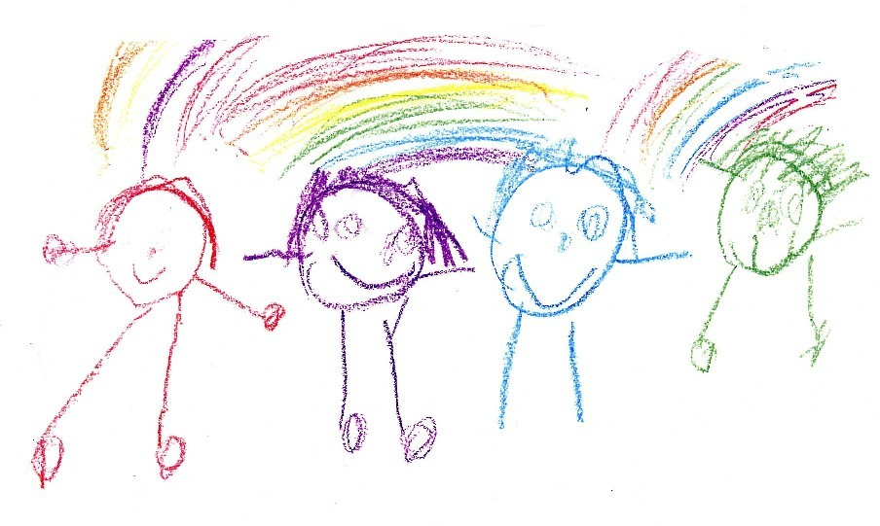
Positive Relationships

At Longstone Nursery, we take the approach that strong positive relationships between staff and our families will support and build on strong positive interactions to promote healthy child development.
We encourage children to develop positive relationships by modelling positive interactions, praising their positive interactions and at times, when children need support, maintaining a consistent, calm approach, allowing a child space and time and talking things over.
We are encouraging throughout their time in nursery the following aspects
- Forming positive relationships with adults and peers
- Expressing their feelings and needs appropriately
- Becoming aware of and respecting the needs of others
- Learning to follow agreed codes
- Playing co-operatively, taking turns, and sharing resources
- Developing positive attitudes towards other irrespective of gender, language, religion and or culture.
It is our aim to promote equality and to foster positive attitudes and commitment to an education for equality. Children in nursery will be prepared for a life in a multicultural society and will be encouraged to appreciate the benefits of diversity.
Staff will strive to build an inclusive environment, where every child can fulfil their potential.

Family Involvement

Families are always very welcome at Longstone Nursery. Currently however, we are somewhat curtailed. However, we encourage families to stay connected with nursery life through our children’s journals and catch up conversations daily. We would encourage you to contribute your child’s interests and wider achievements from home so that we can share these at nursery. We look forward to increased family involvement and enhance partnership working in the furture.
The Parents’ Council, PALS (Parents at Longstone School.) are a very active and supportive group at Longstone. New members from our nursery families are always very welcome. If you are interested in getting involved with our school council, please, speak to nursery staff or contact the school office for information.

Reporting to Parents

Throughout the year we track children’s progress across the curriculum building up individual learning stories for each child in the nursery over time.
Regular observations and photos of your child’s learning experiences are shared with you via our learning journals and we encourage our families to contribute to their own child’s learning stories as much as possible.
In addition, there are opportunities across the year for families to receive progress information in the form of parent consultations and formal written reports.
Age | Reporting Format | Date
2-3 year olds | Parent Consultation | October / November  or  May/June  (depending on start date)
3-4 year olds | Parent Consultation | March /April
4-5 year olds | Parent Consultation  Transition Report | October / November  May / June

Complaints Procedure
If you have any issues or a complaint, you may share that first with nursery staff (if appropriate), and if still unsatisfied, please contact the Deputy Head Teacher, Mrs Masson or the Head Teacher, Mrs Pearston.
If you remain dissatisfied, an approach can be made to Advice and Conciliation Service. This service provides a helpline during office hours and can advise you on how to take further action.
Alternatively, you can put your request in writing to Advice and Conciliation Service
Waverley Court
Level 1 / 2
4 Market Street
Edinburgh
EH 8 8BG
TEL-0131 469 3233
As is the case for all establishments caring for children up to the age of 16. Longstone Nursery Class is monitored by the Social Care and Social Work Improvement Scotland. You may also contact them at:
Social Care and Social Work Improvement Scotland
South East Region
Stuart House
Eskmills
Musselburgh
EH21 7PB
Tel-0131-653-4100
Fax-0131 653 4149 Web Site: scswis .com

