
Sep/Oct Newsletter 2019
Our Vision
For every child to reach their full potential, enabling them to have the skills and confidence to embrace the world we live in.

Our Motto
Good, better, best, we will never rest until our good is better and our better is best.

Dear Families
This month’s newsletter is deliberately brief as we are sending home along with it some leaflets for you to read:
- Home Learning Policy
- Additional Support for Learners – Health and Wellbeing
- Additional Support for Learners – Literacy and Communication
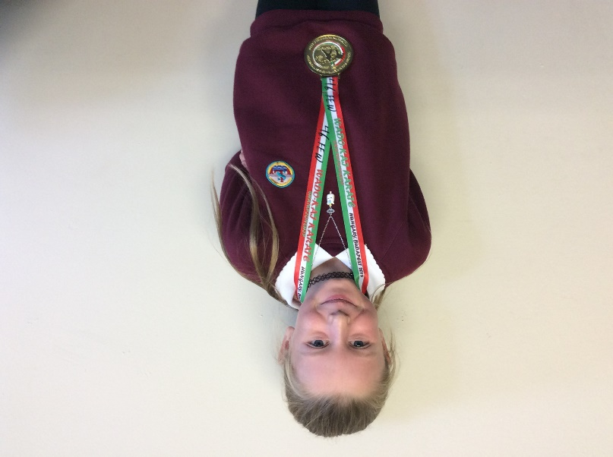
Congratulations Leah Stuart P6
We are so thrilled to share with you that Leah Stuart has recently been crowned British Champion AND European Champion in Karate for her age and weight category. This is an outstanding achievement and we are all so proud of Leah for all of the hard work, training and commitment she puts in. What an inspiration! Well done, Leah!

Staffing Update
We are delighted that our three new Pupil Support Assistants (PSAs) have now started with us. Ms McLaughlin has joined us as a permanent member of staff and we have also welcomed Mrs Esentia and Mr Mills who will be with us until the end of the school session. I am very grateful to our PSA and Teaching staff teams for working so hard and maintaining such high standards whilst we were short staffed and waiting for our new PSAs to start. After the holiday, we will be welcoming teaching students Ms Dawn Bryson to P1M and Mr James McHardy to P2 as they finish in the nursery this week.
School Office
As you may be aware, Mrs Westgarth our school administrator has taken some time off to recuperate following a routine operation and, as Mrs Andrews our office clerical retired over the summer, we have been short staffed in the school office; our business manager Mrs Betts has been doing a fantastic job holding the fort, with a little part-time help from temporary staff Mrs Smith and Ms Giebeler, for which I am really grateful.
Please be aware that, due to the shortage of staff, the school’s admin email account is only being checked on a weekly basis. For a swifter response, please pop into the office, call us or send a note in. Please also be aware that any emails sent to Mrs Westgarth’s email address will not be responded to whilst she is recuperating.

Parent Helpers
A huge thank you to the parents who have helped us out this half term. Help has included volunteering to come on trips, helping with photocopying and laminating, helping in Outdoor Learning sessions, sorting all of the new waterproofs and creating our very own Longstone mini farm on the field. This support has been invaluable.

P7 Shakespeare - To be or not to be…

Excitement mounts as P7’s production of Hamlet at the Brunstane Theatre on October 29th approaches! Please contact the school office for information about tickets.


Yours sincerely,

Angela Pearston - Head Teacher
Dates for your Diary
Friday October 11th | School closed (usual time) for holiday.
Mon.14th – Friday 18th Oct. | Mid-term break
Mon. 21st & Tue. 22nd Oct. | In-service days for staff SCHOOL CLOSED TO PUPILS
Wednesday October 23rd | Pupils resume
Wednesday October 23rd | 3.30pm-4.30pm SPA Football Session P3 and P4
Thursday October 24th | P7 Camp Info. Session 6-7pm
Tuesday October 29th | Flu Vaccination Day
Tuesday October 29th | P7 Hamlet rehearsal (afternoon) performance (evening)
Wednesday October 30th | PALS Halloween Disco P1-P3 6-7pm and P4-P7 7.15-8.30pm
Friday November 1st | Harvest Assembly – send in an item for foodbank on the day
Mon. 4th-Fri.8th November | P1 Registration Week – see office for information
Tuesday November 5th | P4R First Weekly Swimming Session WHEC
Thursday November 14th | P1-3 Road Safety Magic Show (pm)
Mon. 18th - Fri. 22nd | P7 Camp Lockerbie Manor

