
November Newsletter
Our Vision
For every child to reach their full potential, enabling them to have the skills and confidence to embrace the world we live in.

Our Motto
Good, better, best, we will never rest until our good is better and our better is best.

Dear Families
What a busy month we have had. Here are some of the highlights:

P7’s Hamlet Performance and School Camp

We were so proud of all of our P7s who performed Shakespeare’s Hamlet at the end of October at the Brunton Theatre in Musselburgh. Shakespeare Schools Foundation, who organise and run the staff training and pupil workshops that our teachers and P7s attended, described the performance as: ‘passionate, energised, quick paced and mature beyond their years’ – wow!
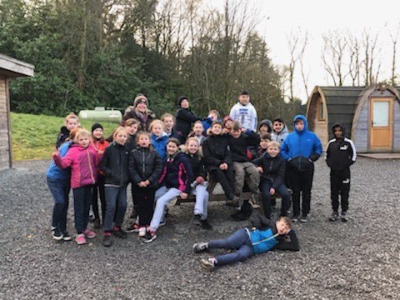
Mrs Masson and Mrs Ross were also extremely proud of our P7 pupils’ attitude throughout their week at Lockerbie Manor. They were enthusiastic, positive, supportive of each other and they all had a fantastic time! Well done, P7, and a huge thank you to Mrs Masson and Mrs Ross for accompanying you on the trip – they had a ball!


P6’s Remembrance Assembly
A huge well done to Miss Jamieson’s P6 class who led our Remembrance assembly this year. Their words and poetry were very moving. We were also very grateful to Longstone parent Mr Rowbottom for arranging a bugler for the assembly.
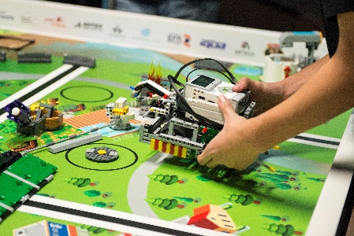
P6 First LEGO League 2019/2020
The P6s from Miss Campbell’s class have this term been taking part in a really exciting project, sponsored and supported by Napier University: First LEGO League. This is the world’s largest STEM (Science, Technology, Engineering, Maths) competition which aims to inspire the engineers of the future by providing the opportunity to research challenges facing today’s scientists, design, build and programme robots using LEGO® MINDSTORMS® technology, develop critical thinking, team-building and presentation skills. The final event is next week – good luck P6s and Miss Campbell! Here’s a link to a short film about the competition: https://tv.theiet.org/?videoid=12184

P6/7 Sportshall Athletics Competition
We were very proud of our P6/7 Athletics team who put in great performances at this year’s Sportshall Athletics Competition at the Jack Kane Centre earlier this month. Here’s the team:
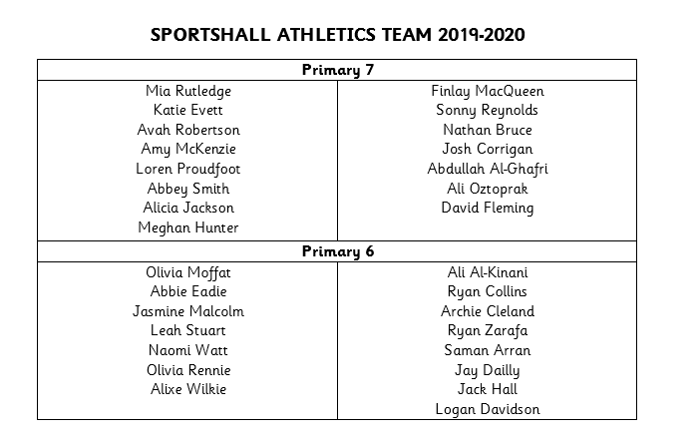
Staffing Update
- We were sad that Pupil Support Assistant Ms Wisely recently moved on to a new post. We wish her well in her new job.
- We are delighted that our new office clerical, Mrs Jahanfar, has now started. Mrs Jahanfar will be working Monday-Friday so she will soon be a familiar face for all of our families. Mrs Smith continues to help Mrs Betts, our Business Manager, in the office on a part time basis.
- We were very pleased to recently recruit Mr McHugh as full-time teacher of P2, covering Mrs Menzies’ maternity leave which starts after Christmas. Mr McHugh will be teaching P2, alongside Mrs Menzies, on Tuesday mornings until the holidays so that he can get to know the class.
- We are currently recruiting a full-time permanent Pupil Support Assistant, as well as a part time Early Years Practitioner, in the nursery and will update families of the outcome of this recruitment asap.

PLaCE – Professional Learning as Critical Enquiry
Our collaboration with Edinburgh University is going well and staff have now had a number of training sessions, supported by the university, on Practitioner Enquiry which is really supporting the staff to look very closely at the learners and learning in their classroom, reflecting on what has worked well and why.
A number of our staff are playing a key role in leading the project - Mrs Mair, Miss McGovern, Miss Cosgrove and Miss Campbell – who alongside Mrs Masson and Mrs Pearston, are doing lots of professional reading to deepen our understanding of improving learning across the school. We are one of five schools from across Scotland involved in this exciting project. Here is a poster that Edinburgh University created about the project to share at the recent Scottish Educational Research Association (SERA) conference:
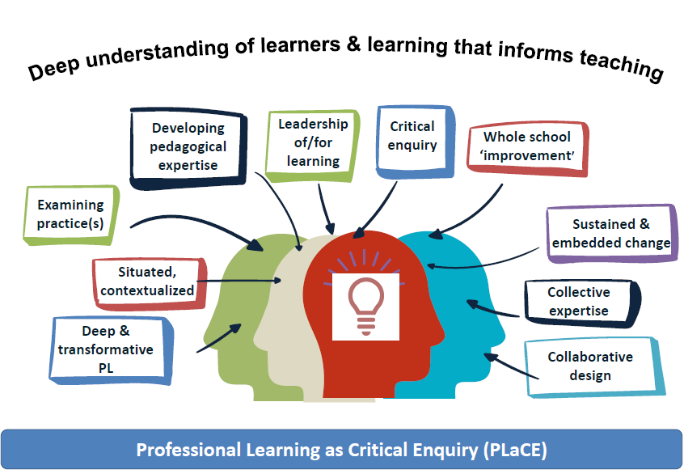

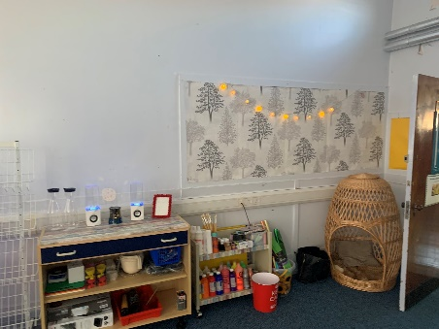
Space to Grow Launches!
Miss McGovern, Mrs Ness and Mrs Robertson have worked tirelessly since August to transform our former library into the fantastic Space to Grow room. This is a wonderful, homely space for learning, for groups and individuals. We are also planning that all children will be able to access the room over time, for a range of activities to support their health and wellbeing.

Christmas Fair Saturday 7th December 12-2pm
Come along to our Christmas Fair on Saturday 7th December. There will be Christmas crafts made by the children, face painting, Santa, hot food and drinks, games and much more. A great way to get in the festive spirit!


Yours sincerely,

Angela Pearston - Head Teacher

Festive Dates for your Diary
Violin and Choir Concert | 4th December 10.40am Main Hall - families of Choir/Violin pupils welcome
Christmas Panto | 11th December 1.30pm Main Hall
Longstone Christmas Fair | 7th December 12.00 – 2.00pm
P1/P2 Nativity (for families) | 10th December 9.30am Main Hall
Nursery Christmas Singing | 11th December 2.15pm Nursery
SCHOOL CLOSED TO PUPILS ELECTION | 12th December
P1/P2 Nativity (for school) | 13th December 9.30am Main Hall
Nursery Santa Visit and Party | 17th December  (Party at nursery – Santa arrives at 10.45am)
P1 Santa Visit and Party | 17th December  (Party Main Hall (pm) – Santa arrives at 2.50pm)
P2 Santa Visit and Party | 18th December  (Party Main Hall (pm) – Santa arrives at 2.50pm)
End of Term 12 noon | Friday 20th December
In-service days | Tuesday 7th and Wednesday 8th January
Pupils resume | Thursday 9th January

