

Hello and Happy New Year
Welcome to our new newsletter, we hope you have had a wonderful Xmas and New year and are enjoying all that Edinburgh and Scotland has to offer!
In this newsletter you’ll find information about what’s on in your area. The activities are open to all members within Edinburgh Garrison. It covers the period from January until the Easter holiday break in April. Full details of all our groups and activities can be found on our posters.
Please ensure you register and book your place for the February trips out and March Sea-life Centre as soon as possible to avoid disappointment!
We value your feedback about how to improve our services, please get in touch to let us know today.

What’s On?

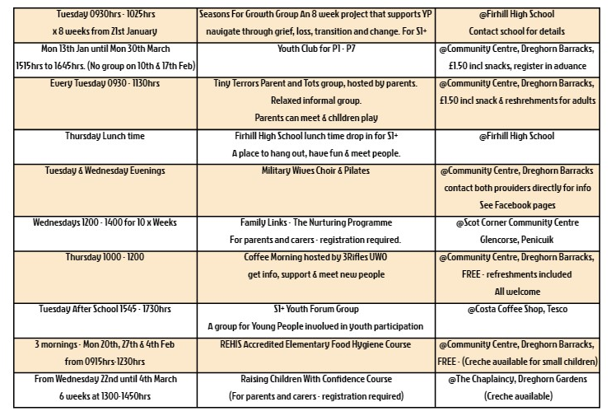


WATCH THIS SPACE - FOR EASTER PROGRAMME

For more information, or to have a chat about any concerns etc. please get in contact!
Army Welfare Service, Building 29, Redford Road, Edinburgh, EH13 9QW
Zakia Yousaf (CDW) – Tel: 0131 310 2840 Mob: 07780 957 291 – Zakia.yousaf100@mod.gov.uk
Stephanie Ireland (Business Support) – Tel: 0131 310 2845









