Our Vision
For every child to reach their full potential, enabling them to have the skills and confidence to embrace the world we live in.
February/March
Newsletter
Our Motto
Good, better, best, we will never rest until our good is better and our better is best.


Motto, Vision, Values and Aims
We hope you enjoyed reading our new Motto, Vision, Values and Aims that we sent home with the last newsletter. Our next step is to share these as widely as possible and ensure that they underpin all of our work at the school.

Positive Relationships Policy
There is currently a lot of work going on in school, led by Mrs Masson, reviewing our systems and approaches to managing behaviour and promoting positive relationships. Along with the views of parents sought at the last parents evening, we have gathered the views of pupils and staff about what our school rules should be. We have settled on the three rules below. Our next steps are to embed these rules in the school, review our rewards systems and finalise our Positive Relationships policy. As with all of our school developments we look to educational research and best practice to inform our improvements. Our work on positive relationships has been hugely influenced by the work of Paul Dix and Bill Rogers. Here are our rules:
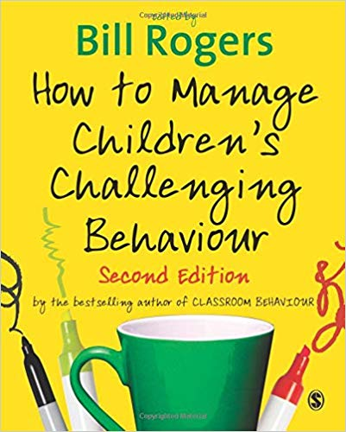

OUR RULES
BE RESPECTFUL
BE SAFE
BE RESPONSIBLE
OUROU OUR SCHOL RULES
BE RESPECTFUL
BE SAFE
BE RESPONSIBLEOUR

Sports Committee – Parent Volunteers needed
Mrs Menzies (our P3 teacher and Health teacher leader) is setting up a sports committee with Lorna Norman (our Active Schools coordinator) and we are looking for parents to join the group. The commitment would be one meeting a term and we are hoping to work towards achieving a Sports Scotland Schools Sports Award. Please let the school office know if you are interested by 22nd March.
PALS (Parents At Longstone School) Update
We are very lucky to have an incredibly supportive parent group PALS who support the school in a number of ways:
- Fundraise for the school
- Organise fun events for the school community
- Contribute to school improvement plans
Here are just some of the great things PALS have done over the past two years:

*Quiz night *subsidised most trips e.g. P3 Museum, P1/2 Canty Bay, P5 Holyrood
*Kingsknowe fundraiser paid for new Scooterpods
* set up new communication app for parents Class List *paid half of the panto
*gave the school funds to support children living in poverty
*Christmas fairs *Halloween and Spring discos *bought waterproofs for nursery
*paid for a hoodie for each P7 *Burns Night *bought waterproofs for outdoor learning
*bought ICT e.g. IPads, SMART boards

The school cannot overemphasise how supportive PALS is to the work of the school. Without their support we would not have many of the extra resources we have and many trips and events would be double the cost to parents.

PALS Annual General Meeting (AGM) is on Tuesday March 12th at 7pm in the school library. Our Chair Rachel Bonnar, Vice Chair Lauren Knight and Treasurer Martina Proudfoot will be stepping down and we need to vote in new people to these positions. If we do not get anyone to stand for these positions then PALS will fold. This would be really devastating so we really need people to step forward for these roles.

Can I take this opportunity to thank Rachel Bonnar, Lauren Knight and Martina Proudfoot for all of their work over the past two years. They have worked tirelessly for the school since taking up their positions and we cannot thank them enough for the difference they have made to our school community – THANK YOU!

We look forward to seeing as many of you as possible at the meeting on Tuesday March 12th at 7pm in the school library.


SAVE THE DATE!
Free on the weekend of 23-24th March?
If so, put on your wellies and help us create

our new school garden. We need as many
volunteers as possible – from 9am both
days. Please bring gardening tools
and a wheelbarrow if you have one.

Lord Provost Visits Longstone Primary
We were very excited to receive a visit from Edinburgh’s Right Honourable Lord Lieutenant and Lord Provost Frank Ross to assembly recently. The Lord Provost came to speak to the children about getting their ideas for the council’s 2050 vision for the city https://www.edinburgh2050.com/.

Some of our Longstone pupils’ ideas for Edinburgh 2050 include:
Flying Cars Homes for everyone



Catriona Place2Be
It is with very mixed emotions that I share with you that Catriona MacInnes, our Place2Be School Project Manager, is leaving Longstone at Easter. Catriona, for the past two years, has been an invaluable member of our Longstone team and not only has she been a great emotional support for our pupils, she has been extremely supportive of staff as well as helping to shape our approaches to positive relationships. We are really sad that Catriona is moving on but we are also excited for her as she will be moving to the Western Isles to take up the wonderful opportunity of setting up an art therapy service. We will miss her but wish her all the very best for this exciting new adventure!

School Improvement Plan (SQIP) and Attainment Summary
We have created a family-friendly SQIP and Attainment summary which you will give parents when they come for their parent appointments. These summarise the information that is available in the full SQIP which is on our website. You can also get more information about the school’s performance on the government’s dashboard: https://www2.gov.scot/Topics/Statistics/Browse/School-Education/Dashboards

Spare Clothes Nursery
Do you have any spare children’s clothes you can give the nursery? They would be grateful for any of these items in good condition: underwear, socks, tops, trousers, jumpers, hats, gloves.
One of the Wise Men travelled 650 miles to get from his home town to Bethlehem. If he travelled for 5 miles each day, how many days did his journey take?

Answer – 130 days

Family Maths Challenge
Well done to Lucy Reed who won the last
Family Maths challenge! This month’s, on
a money theme to tie in with Money Week, is at the end of the newsletter.

SCAN TO TAKE YOU TO OUR TWITTER FEED - this is regularly updated to show recent events and information.


Cross Country Team – Meadows Festival
We are all extremely proud of our Meadows Festival Cross Country runners who competed in the race on Monday 4th March. All of the children completed the challenging 1000m course around the Meadows and the team spirit was excellent, with the children being very supportive of each other! All in all the team won a staggering 8 medals, including two for first place in the P7 Girls and P7 Boys race. The P7 Girls team also dominated their race with incredible performances, winning four of the five medals! The top fastest finishers from this event will be competing in a bigger cross country competition on March 25th. Special mention to Any McKenzie who was selected for the team but who couldn’t compete on the day due to an injury.

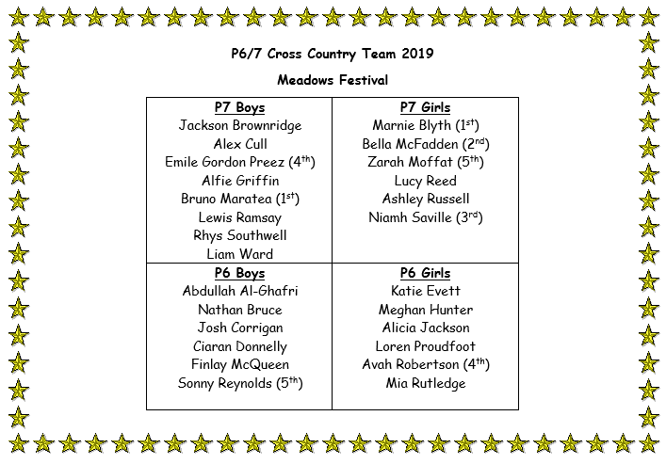

Dates for your Diary
Monday March 11th – Friday March 8th | MONEY WEEK – see separate timetable  RBS Moneysense; My Bnk; Money Bus
Tuesday March 12th | PALS AGM 7-8.30pm School Library
Thursday March 14th | Parent Appointments
Friday March 15th | Red Nose Day
Tuesday March 19th | NSPCC Online Safety workshop for parents 1.30pm
Friday March 22nd | Parent Appointments
Saturday March 23rd and Sunday March 25th | Garden development – volunteers needed
Monday March 25th | P6/7 Cross country team to EPSSA competition (am)
Monday March 25th | P5 year group trip to see author Lauren Child
Tuesday March 26th | P4 year group to Firrhill Handball event (pm)
Wednesday March 27th | P6 Buddying party at Merchiston school (pm)
Friday March 29th | Dress Down Day
Wednesday April 3rd | P6/& Swim team to Sim and Dive gala (am)
Friday April 5th | End of term – pupils wear uniform as usual


Angela Pearston
Head Teacher


Monthly Family Maths Challenge



Show your mathematical thinking here:

Answer:

Family of (name and class) ________________________________________________
CUT OUT THE SLIP AND HAND IN TO THE SCHOOL OFFICE by 31/3 TO WIN A PRIZE!!

Family Maths Challenge

Use these strategies from Jo Boaler Professor of Mathematics at Stanford University (https://www.youcubed.org/) which we use in school:



