
Dear parents,

We have some exciting news! Over the last two years, we have been working on becoming a Rights Respecting School.

Being a Rights Respecting School means we aim to place children’s rights at the heart of Longstone Primary School.

We found out in January of this year that we…

…have achieved our Rights Respecting Bronze award!
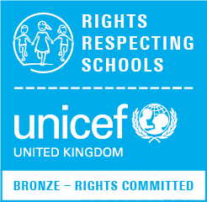

To earn this award, we set up a pupil steering group, made up of one child from every class. They were tasked with raising awareness across school of the rights that children are afforded in the United Nations Convention on the Rights of the Child.

The group set up a tidy cloakroom initiative (article 24: the right to a clean and safe environment) and a ‘right of the month’ competition (article 42: the right to know your rights). They regularly share information related to children’s rights in assemblies.

Every class has a classroom charter that is linked to children’s rights. Where appropriate, teachers help children make links between their learning and children’s rights.

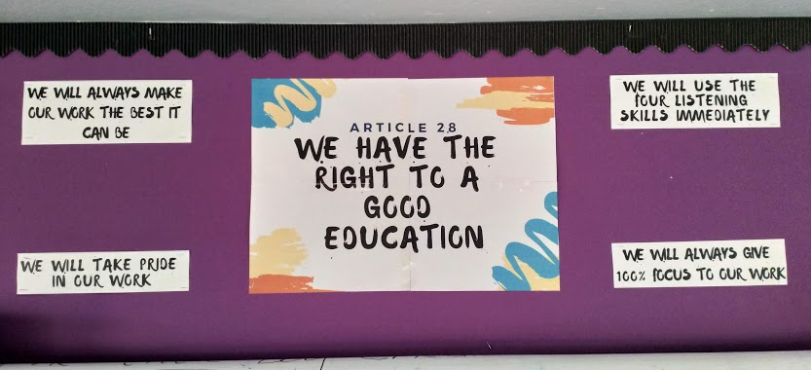

We have looked at the Global Goals and participated in the World’s largest lesson, sharing these goals across the school with class lead assemblies to ensure we are thinking globally as well as locally. We see how the Rights of the Child are inextricably linked and woven through the Global Goals.
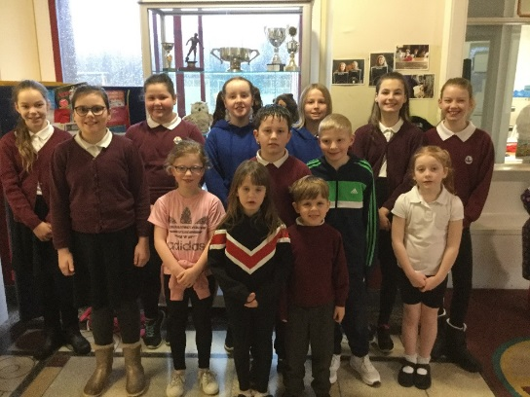
A huge thank you to all of the children who have been involved with our Rights Respecting steering group so far.

We will now build towards achieving the silver level award. This will involve campaigning locally for children’s rights in the community and ensuring that the language of children’s rights is woven throughout all school policies.

The journey is just beginning, and we would love to get some parents involved in the next step.

If you are passionate about children’s rights and would be interested in meeting with our pupil group once a term, get in touch with Mr Hawkey or Mrs Masson.

