
November/December Newsletter

Athletics Team
Well done to our P6/7 Athletics team who competed in the Sportshall Athletics competition on Monday 19th November. The team came third overall, earning them a place in the final in January. Here’s the winning team:
P7  Amy Junor  Jackson Brownridge  Sophie Connon  Bella McFadden  Alfie Griffin  Uswah Noor  Thomas O’Donnell  Lewis Ramsay  Sophie Clingan  Sidra Arran  Finlay Storie  Rhys Southwell  Rhys Coll  Del Valance  Bruno Maratea  Zarah Moffat  Niamh Saville  Ashley Russell  Brooke Carter  Ana Puskina  Bo Buckler Scott | P6  Abdullah Al-Ghafri  Nathan Bruce  Ciaran Donnelly  Finlay MacQueen  Ali Oztoprak  Leah Cave  Meghan Hunter  Eve Malcolm  Abbey Smith  Avah Robertson

Longstone’s Got Talent – Competition Winners
Congratulations to Cailyn Angus in P5 whose Christmas card design was chosen by MSP Gordon MacDonald for his official Christmas card.
Well done also to Euan Pearson in P5 whose Winter Windows design has been selected to be displayed on the Meadowbank hoardings over the festive period.

Staffing
We are very pleased that Ms Teroni has now started as teacher of P4/5, covering Miss McGovern’s maternity leave. We also recently recruited Viv Betts to the post of Business Manager. Viv will be joining the team in February.

Outstanding Performances
We have had some outstanding performances in the past few weeks. P6 presented a very moving Remembrance Assembly to the school and parents, P7s shone in their spectacular performance of A Midsummer Night’s Dream at the Brunton theatre and special mention to our P1 and P2 children who wowed us with a brilliant nativity this week. What talented children and staff we have! We are looking forward to our Violin and Choir Christmas concert which is Tuesday 18th December at 11am.

Baby News
I am delighted to let you know that Miss McGovern has had a baby boy, Rudi! We are so thrilled for her and can’t wait to meet him.

Pupil Council
Our Pupil Council, this term, have been consulting classes on the development of the garden at the front to the school. The Pupil Council reps have settled well into their new role and have been learning how our meetings run with an agenda and minutes. I am very impressed so far with their commitment to this important role. Here are the reps:
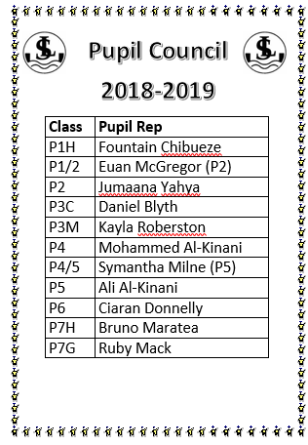

House Captains Update
Our House and Vice Captains have also been busy this term collecting house points and organising fun events for Children in Need and Anti-Bullying week. Next up, they’ll be leading a house meeting in the New Year and then they’ll be turning their attention to organising Longstone’s Got Talent. We can’t wait!

SQIP
As shared in August’s newsletter, our improvement plan this year continues to focus on raising attainment, equity, skills for work and health and wellbeing. In particular, we are developing our approaches to learning and teaching in writing and staff have attended training to support this by literacy consultant James Clements https://global.oup.com/education/content/primary/experts/james-clements/?region=uk and are trialling the authority’s new framework to raise attainment in writing too.
All of our teachers are currently doing a small piece of research, and have chosen a new strategy in writing to try out and then measure the effect of this – we call this Professional Enquiry. Here are the strategies from the framework we’re looking at:
- Teach children to think like a writer
- Teach children about the process rather than the product
- Sustain a focus on spelling and handwriting
- Inspiration and purpose are important
- Look at how authors use language in good quality texts
- The importance of talk for writing
- Grammar and punctuation are crucial
- Get children to write lots
- Continue to develop vocabulary
- Provide high quality feedback for improvement throughout the writing process
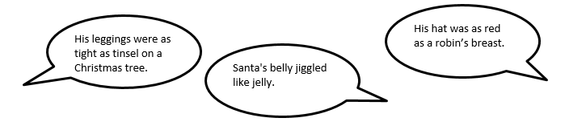
Mrs Masson and I have been joining writing lessons this term to see this work in action and we have been very impressed with the engagement of the children and with the quality of teaching. Look at our Twitter feed for photos from some of these lessons. Here are some festive highlights from P5s lesson on similes:

SCAN TO TAKE YOU TO

OUR TWITTER FEED

Christmas Fair
A huge thank you to PALS chair Rachel Bonnar and her fantastic team for working so hard to organise such a brilliant fair. It was a great event with Santa, mulled wine, games galore and much more. So far, the revenue from the fair looks to be in the region of £2000.

Fundraising for Ruaridh McQueenie
We are delighted that the children’s fundraising from the Christmas Fair (from their various stalls), totalling £346, will go to support the fundraising for Ruaridh McQueenie, a former Longstone pupil who is raising funds for ongoing cancer treatment. This Friday, the choir will also be raising money for Ruaridh by singing at Edinburgh airport. Here is the link to Ruaridh’s fundraising page: https://www.justgiving.com/crowdfunding/ruaridh-mcqueenie

Festive Dress Down Friday 21st December
We are having a special Festive Dress Down on Friday 21st December and funds raised will to go to supporting Ruaridh McQueenie. Wear something festive or just your own clothes. Suggested donation £1.

Family Maths Challenge
I was absolutely delighted that we had so many entries to our last Family Maths Challenge. The winners were the family of Charlie and Sonny Reynolds. Our next challenge, on a Festive theme, is at the end of the newsletter. Entries to be in by January 18th. Good luck!

Army Links
We have been grateful that Zak from the Army Welfare Community team has been dropping in to see our children of forces families every Tuesday lunchtime. She will be continuing to do this in the New Year. Thanks also to George in P1’s dad who organised for us to borrow tables from the army for the fair at the weekend.

Christmas Gifts for Staff
We would like to remind parents that, whilst all gifts are gratefully received, there is absolutely no expectation to buy staff gifts. We love our jobs which are so rewarding! Something personal and handmade is very welcome.

Uniform
If you are buying any uniform over the holiday, please remember to purchase according to our uniform policy. In particular, I would like to remind families that outdoor shoes must be black, trousers grey or black and jumpers/cardigans maroon. No jeans.

PRIMARY 1-3
Shirts/Polo shirts  Jumpers/sweatshirts/cardigans/blazers  Trousers/shorts/skirts/pinafores  Summer gingham dresses | White  Burgundy  Grey  Red and White
PRIMARY 4-7
Shirts/Polo shirts  Jumpers/sweatshirts/cardigans  Trousers/shorts/skirts/pinafores | White  Burgundy  Black
PRIMARY 7
Hoodie  Trousers/skirts/shorts/culottes (NO JEANS) | Colour decided by the P7s each year*  Black
FOOTWEAR across all years should be BLACK

Dates for your Diary
Friday December 21st | Last day of term
Monday January 7th | Holiday
Tuesday January 8th | In-Service - school closed to pupils
Wednesday January 9th | Pupils return to school
Monday January 21st | Active Schools Clubs start
Friday January 25th | Coffee Morning for Parents in old nursery
Tuesday January 29th | Last swimming session P4s
Monday February 11-15th | Mid Term February Holiday

Have a lovely Christmas break!

Angela Pearston
Head Teacher

LONGSTONE PS
COFFEE MORNINGS
Second Friday of Every Month
Come along to the old nursery building and find out about what our Parents Group PALS have been doing.
Next date:
Friday 14th December

Last Friday of Every Month
Come along to the old nursery building for a cuppa and a chat. Meet other parents. Find out about the school and the local community.
Next date:
Friday 25th January



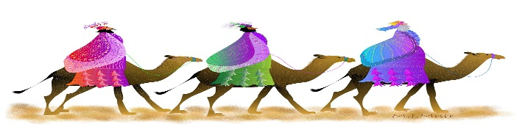

One of the Wise Men travelled 650 miles to get from his home town to Bethlehem. If he travelled for 5 miles each day, how many days did his journey take?

Show your mathematical thinking here:

Answer:

Family of (name and class) ________________________________________________
CUT OUT THE SLIP AND HAND IN TO THE SCHOOL OFFICE by 18/1 TO WIN A PRIZE!!
Monthly Family Maths Challenge

Family Maths Challenge

Use these strategies from Jo Boaler Professor of Mathematics at Stanford University (https://www.youcubed.org/) which we use in school:

