
January Newsletter

Vision, Values and Aims

In the newsletter is our draft school Vision, Values and Aims. After a considerable amount of consultation with pupils, staff, families and the local community, led by Mrs Masson, we are delighted to be sending this home. Please let us know what you think of these by emailing us at admin@longstone.edin.sch.uk. You will see that we have also adopted a new motto - created by Mrs Menzies - which we think reflects the high expectations we all have at Longstone - we hope you like it.

Bronze Rights Respecting Schools Awards
I am delighted to share with you that we have now received our Bronze Rights Respecting Schools Award. Well done to our pupil group the Rights Respecters who have been leading this with Mr Hawkey and Mrs Masson.
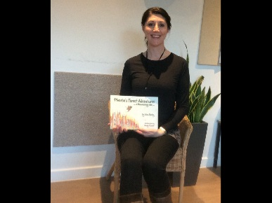
‘Phoebe’s Forest Adventures’ by Nina Fairley
Inspired by her Forest Kindergarten work in the school nursery, Nina Fairley (Early Years Practitioner) has written a wonderful story book entitled ‘Phoebe’s Forest Adventures’. All of the children in the nursery were involved in creating the artwork used in the book with the help of professional artist, and Longstone parent, Mandy O’Connor. The book project also involved workshops for the children with Whitewater Publishing, giving the children the opportunity to learn all about how books are made. This was a truly inspirational project. Copies are available to purchase from the school office.

School Uniform, PE Kit and Indoor Shoes
Can I remind families that jeans and joggers are not school uniform and children should wear school trousers/skirts? Jumpers should be maroon except for P7 who have a school hoodie. I have noticed quite a number of girls wearing leggings which are also not uniform – the high school, in fact, take a very firm stance on leggings.
Children also need a PE kit in school every week (t shirt and shorts) for PE lessons.
A final plea is to remind parents that children need to have a separate pair of indoor shoes – this really helps keep our carpets and corridors clean, especially in this weather. We are able to help families purchase uniform and kit so let us know if we can help.
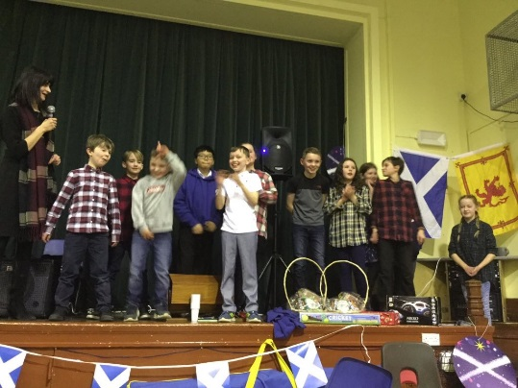
Scots Night
A huge thank you to PALS for organising another excellent Scots Night last week. The children who recited their Scots poems did a fantastic job and we all enjoyed a good jig too!

Staffing
We are delighted that our new Business Manager Viv Betts has started. We have also welcomed new staff in our nursery: Iona Gorringe (Early Years Assistant), Pamela Young (Early Years Practitioner) and Lesley Murdie (Early Years Domestic).


SCAN TO TAKE YOU TO OUR TWITTER FEED - this is regularly updated to show recent events and information as well as showcasing the learning going on across the school.

Dates for your Diary
Monday February 11-15th | Mid Term February Holiday
Monday February 11-15th | Longstone Community Council Meeting
Monday February 18th | School resumes: pupils and staff
Tuesday February 19th | PALS meeting (all welcome) 7-8.30pm School Library
Friday February 22nd | Coffee morning 0900-1030 Old Nursery
Friday February 22nd | Dress Down Day
Monday March 4th | P6/7 Cross country team to Meadows Festival (am)
Monday March 11th – Friday March 8th | MONEY WEEK  Money sense workshops P1-3  My Bnk workshops P4-5  Money Bus P6-7
Tuesday March 12th | PALS AGM 7-8.30pm School Library
Friday March 15th | Red Nose Day
Tuesday March 19th | NSPCC Online Safety workshop for parents 1.30pm
Saturday March 23rd and Sunday March 25th | Garden development – volunteers needed
Monday March 25th | P6/7 Cross country team to EPSSA competition (am)
Tuesday March 26th | P4 year group to Firrhill Handball event (pm)
Friday March 29th | Dress Down Day
Wednesday April 3rd | P6/& Swim team to Sim and Dive gala (am)
Friday April 5th | End of term – pupils wear uniform as usual

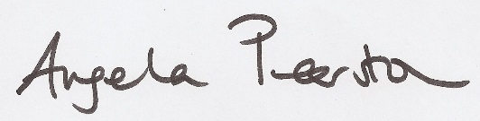
Angela Pearston
Head Teacher

Longstone Primary School

Vision, Values and Aims

Our School Motto
Good, better, best, we will never rest
until our good is better and our better is best

Our school vision is for every child to reach their full potential, enabling them to have the skills and confidence to embrace the world we live in.

This vision is one based upon our core values which means we are:
- Caring
- Respectful
- Resilient
- Proud
- Creative

At Longstone Primary School we aim for everyone to:
- Be happy safe and secure.
- Be equal and included.
- Be confident and ambitious.
- Be responsible for themselves and their learning.
- Be creative and enquiring.
- Be healthy in body and mind.

We want to develop skills that enable our pupils to:
- Grow and learn through play.
- Learn effectively with confidence, collaboratively and with increasing independence.
- Know themselves as learners.
- Use digital technologies to enhance their learning.
- Live and work in the 21st Century.

