
September 2018

Dear Families
September was another busy month, here are some of the highlights as well as some essential information for the month ahead…

Talented P7 Footballers
Well done to Longstone footballers Bruno Maratea, Lewis Ramsay and Rhys Southwell who recently participated in the Edinburgh P7 Football Select Squad Trials. We are very proud of your efforts. Special mention to Rhys who made it through to round two of the trials! Well done, boys.

New House Captains
I am delighted to announce our new House Captains:
Redhall | Kingsknowe | Juniper Green | Slateford
House Captain  Thomas O’Donnell  Vice House Captain  Sophie Connon | House Captain  Ella Scott  Vice House Captain  Sidra Arran | House Captain  Ashley Russell  Vice House Captain  Lewis Ramsay | House Captain  Zarah Moffat  Vice House Captain  Marnie Blyth

New Garden in Front Playground

Thank you to the many families who gave us their ideas for developing the new front garden when they attended for parents appointments. Longstone parents Karen and Duncan Jameson have been very busy helping with the new front garden which has now been levelled out and strimmed. I am delighted to let you know that Mrs Jameson successfully applied for a Scotmid Community Grant for the project and we have been awarded £270 to buy seeds, plants and gardening equipment. Mrs Jameson is still looking for parents who would be willing to help her with this project. If you have skills such as gardening, painting, joinery or if you have time and would like to help out in any other way, please let the office know asap. We’ve not had any volunteers yet so are hoping that some people come forward to help with this really exciting project.

Yarn Bombing
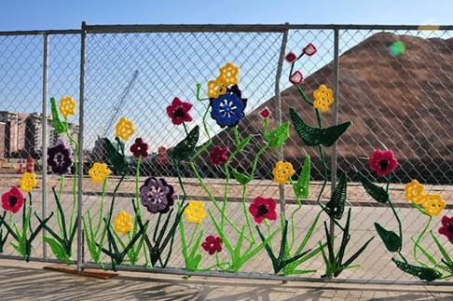
Do you enjoy knitting / crocheting (or know someone who does)?
If so, can you help us on our quest to ‘Yarn Bomb’ the school fence?
We hope to display our artwork in the spring, giving you plenty of time to produce your most colourful creations! Please hand in any knitted / crocheted items to the school office.

Golden Time Clubs
We run a very successful programme of pupil-run clubs at lunchtime and we have been gathering ideas from the pupils about the clubs they would like this term. The children have come up with lots of ideas and we were wondering if there were any parents who would be available to come in to help with this by running a club on Fridays during Golden Time 1130-1200? This could be a one off, for a few weeks, or for a term. The children were particularly interested in arts, craft and baking. Please contact the school office if you think you can help.

Robotic Lawnmowers
I wanted to let all parents/carers know that our robotic lawnmowers are in operation at all times with the exception of:
Monday-Friday between 1000-1330
Saturday between 0800-1300
Before and after school, children must be suitably supervised and asked not to touch the lawnmowers.

Baby News
We are delighted to share with you that Mrs Summers has had a baby girl called Emma and Mrs Ross has had a baby girl called Ailsa. Congratulations to them both!


Walking Bus Survey
As communicated in previous letters, our School Travel Plan group are keen to trial a walking bus. Unfortunately, we have had very few respondents to the surveys that went out last term so coming home today is another paper survey for all families. We would be really grateful if you could take 5 minutes to complete the survey.

Flu Vaccination Day – Friday 26th October
Please note that Flu Vaccination day is Friday 26th October. Letters have been sent out to all families from the school nursing team about this.

Photos – Monday 29th October
Please note that school photograph day is Monday 29th October.

Water Bottles
Please can I remind parents that pupils should only have water in their water bottles for drinking throughout the day and not juice–this is for dental health. All children are asked to bring in a water bottle and these are either kept on desks or in trays in the classroom for children to access throughout the day.

Army Welfare Community Development
I was really pleased to recently meet with Zakia Yousaf from the Army Welfare Community Development team and look at ways that we can develop links between the team, the school and our pupils from armed forces families. Zakia is going to be popping into school this week to chat with pupils at lunchtime and then after the October break she will be coming down weekly to run a drop-in club.


Coffee Mornings
Our next coffee morning, organised by parent Tracey Lee, is at 0900 on Friday 12th October for a PALS catch up – come along to hear what PALS have been planning and to give your views. The next coffee morning after that, organised by parents Sara Twigg and _____ will be from 0900 on Friday October 26th and Zakia from Army Welfare will be popping along to say hello. All families welcome – drop in between 0900 and 1030 to the old nursery.
Kingsknowe Family Fun Day
Come along to the newly refurbished Kingsknowe Roadhouse on Friday 12th October from 1.30-3.30pm for lots of fun family activities. Ticket price is £2.50 and proceeds will go towards the development of the school playground.

Class List
You will have received a letter from PALS about their new app, Classlist. The app is a great way to connect with other parents and keep up to date with what’s happening. Go to Classlist.com to join and find out more.

P7 Shakespeare Schools Foundation – A Midsummer Night’s Dream
P7s have been working really hard on the production and behind the scenes of their performance of A Midsummer Night’s Dream as part of this year’s Shakespeare Schools Festival. The performance is on Thursday 8th November at the Brunton Theatre. Please contact the school office if you would like tickets.

RBS Code Club
Following a suggestion by Josh’s family in P6, we have been in talks for around a year now with RBS about a collaborative coding project. I am delighted to let you know that we are now almost ready to get the project off the ground and that RBS will be coming in after the October break to run three weekly coding sessions in P6 and then, after these, they will be running a lunchtime P6 code club. We are delighted to have established this new business link and would like to thank Josh’s family for the suggestion.

Home Learning
Following discussion with staff, it has been agreed that Maths home learning will be provided by class teachers for each class. Teachers can decide whether to do a weekly task or a Maths Home Learning grid from which children can choose activities to do on a weekly basis – this will be at the discretion of teachers. As with last session, all children P1-P7 should have a Sumdog passwords and are encouraged to do Sumdog regularly – little and often is recommended. If your child does not have access to a Smartphone, tablet or computer to do Sumdog please let us know and we can arrange for your child to use a school device.
We are currently drafting the new Home Learning policy and plan to share this with PALS and consult with the wider parent body on the draft policy later this term.
Other Longstone Primary Policies
Please note that our Child Protection policy which was created last session has now been added to the ‘Information’ section of the school website.
We will also be creating a Positive Relationships policy this term and the views of families, gathered at parents evening, along with the pupil and staff views will all inform this policy. For general information on our current approach to promoting Positive Relationships and dealing with bullying, please refer to our School Handbook which you can find on the same part of our website.

Family Maths Challenge
Well done to the family of Megan and Cerys Campbell who were the winners of last term’s final Family Maths Challenge. Our first challenge of 2018-2019 is at the end of the newsletter. Good luck! Entries to be handed in to the office by Friday October 26th.

Yours sincerely,
Angela Pearston
Angela Pearston - Head Teacher

SCAN TO TAKE YOU TO LONGSTONE PRIMARY SCHOOL’S:


WEBSITE TWITTER FEED

Dates for your Diary
Tuesday October 2nd | P7 company to Shakespeare Workshop Brunton Theatre (am)  P7 backstage team – acting workshop in school
Thursday October 4th | P7 to Handball Festival at Firrhill High School
Monday October 8th - Friday 12th | P7 to Residential Camp at Lockerbie Manor 1000
Tuesday October 9th | PALS meeting Kingsknowe Roadhouse 1900-2030 All Welcome
Wednesday October 10th | P4/5 Trip to Craigmillar Castle
Friday October 12th | Coffee Morning PALS catch up 0900-1030 Old Nursery
Friday October 12th | P7 return from Residential Camp at Lockerbie Manor 1200
Friday October 12th | School closed (usual time) for holiday.
Friday October 12th | PALS Fundraiser (pm) Kingsknowe Roadhouse
Monday 15th – Friday 19th October | Mid-term break
Monday October 22nd | In-Service - school closed to pupils
Tuesday October 23rd | Pupils resume
Thursday October 25th | PALS Hallowe’en Discos
Friday October 26th | Flu Vaccination Day
Friday October 26th | Coffee Morning 0900-1030 Old Nursery
Friday October 26th | DRESS DOWN DAY
Monday October 29th | School photo day
Wednesday October 31st | Dutch Delegation to visit school to see Health and Wellbeing practice
Friday 2nd November | Harvest Assembly – more information to follow
Monday 5th-Friday 9th November | P1 Registration Week – contact the school office for more details
Thursday 8th November | Shakespeare  P7 to theatre rehearsal (pm)  Performance - evening
Monday 19th November | P6/7 Athletics Team to Sportshall Athletics competition (time and pupils tbc)


Monthly Family Maths Challenge
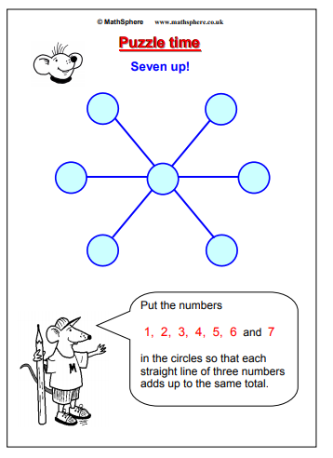

Family of (name and class) ________________________________________________
CUT OUT THE SLIP AND HAND IN TO THE SCHOOL OFFICE by 26/10 TO WIN A PRIZE!!
Monthly Family Maths Challenge

Use these strategies from Jo Boaler Professor of Mathematics at Stanford University (https://www.youcubed.org/):
