
Second Level (P5-P7)
-Split a number up to
100,000 into its place value parts

- Split a decimal number (up to three decimal places e.g. 2.457

-Explore different ways of splitting up numbers eg. 4800 is 4000+800 or 24000 x2

Combining and Partitioning Numbers
Skills Progression

Start at the highlighted
step.
-Split a number up to
100,000 into its place value parts
e.g. 463,709 is
4 hundreds of thousands,
6 tens of thousands etc

- Split a decimal number (up to two decimal places)
e.g. 2.45 is
2 ones, 4 tenths and 5 hundredths

Split a number up to
10,000 into its place value parts
e.g. 36,153 is
3 tens of thousands
6 thousands, 1 hundred, 5 tens and 3 ones.

Second Level Combining and Partitioning Numbers

MATHS FRAME PARTITIONING
https://mathsframe.co.uk/en/resources/playgame/16
- A good challenge as asks learners to find different ways of splitting up numbers.
- Choose level from four levels:
- 3 digit numbers
- 4 digit numbers
- numbers up to 2 decimal places
- numbers up to 3 decimal places.

TOP MARKS PLACE VALUE CHARTS
https://www.topmarks.co.uk/place-value/place-value-charts
- Choose ‘Practise’ Mode and make numbers, including decimals.

These links are on the school website in the ‘Maths’ folder in the ‘Learning’ tab.

Tick and date each activity you complete. You must complete at least four activities this month as well as Sumdog if possible.
ICT GAME | ICT GAME | ICT GAME | WORKSHEET 1
WORKSHEET 2 | 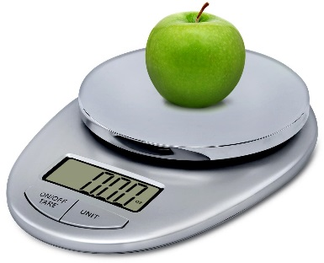  INTERACTIVE – COOK  Bake a cake/make soup. Talk about the quantities. E.g. 500g of flour – What are all the ways we could make 500? Use electronic scales to weight ingredients and talk about the value of digits. |   INTERACTIVE - SHOP  Use an IKEA or Argos catalogue. Select an item, for example a camera that costs £399.99. Ask your child about the money they could use to buy the item - How many ten pound notes would you need to buy this camera? Why? How many £5 notes would you need to buy this camera? Why? Repeat using different items and different prices. For a challenge, try adding two items together or look at property for sale for larger numbers https://espc.com/ or cars.
SUMDOG | SUMDOG | SUMDOG | SUMDOG
Speak to your child’s teacher if you need a new SUMDOG password.
An example schedule of activities:

Week 1 | Interactive Activity 1 or  ICT Games | Sumdog
Week 2 | Worksheet 1 | Sumdog
Week 3 | Interactive Activity 2 or  ICT Games | Sumdog
Week 4 | Worksheet 2 | Sumdog
