
First Level (P2-P4)
- Split a number up to 1000 into hundreds, tens and ones (its place value parts) e.g. 452 is 4 hundreds, 5 tens and 2 ones.

Combining and Partitioning Numbers
Skills Progression

Start at the highlighted
step.
- Split a number up to 100 into tens and ones (its place value parts) e.g. 36 is 3 tens and 6 ones.

- Know number bonds up to 10 e.g. number stories for 5
0+5=5, 1+4=5, 2+3=5, 3+2 = 5, 4+1=5, 5+0=5
- Use number bonds to get to/from a decade e.g. 36+?=40

First Level Combining and Partitioning Numbers

STEP ONE OF LADDER - NUMBER BONDS
HIT THE BUTTON
https://www.topmarks.co.uk/maths-games/hit-the-button
- Choose ‘Number bonds’ then choose ‘Make 10’ or ‘Make 100’.

STEP TWO OF LADDER – PLACE VALUE UP TO 100
BBC STARSHIP PLACE THE PENGUIN
http://www.bbc.co.uk/schools/starship/maths/games/place_the_penguin/big_sound/full.shtml
- Choose Unit One.
ICT GAMES SHARK NUMBERS
http://www.ictgames.com/sharkNumbers/mobile/index.html
- Choose numbers up to 99.

STEP THREE OF LADDER – PLACE VALUE UP TO 1000.
BBC STARSHIP PLACE THE PENGUIN
http://www.bbc.co.uk/schools/starship/maths/games/place_the_penguin/big_sound/full.shtml
- Choose Unit Two.
ICT GAMES SHARK NUMBERS
http://www.ictgames.com/sharkNumbers/mobile/index.html
- Choose numbers up to 999.
These links are on the school website in the ‘Maths’ folder in the ‘Learning’ tab.

Tick and date each activity you complete. You must complete at least four activities this month as well as Sumdog if possible.

ICT GAME | ICT GAME | ICT GAME | WORKSHEET 1
WORKSHEET 2 | INTERACTIVE  Use beans, pasta or go outside and use stones. Place a pile of them in front of your child and show that it is easier to count them in groups of ten. First make groups of ten, then count the tens and then the ones separately.  Get them to make numbers by putting the beans/pasta in tens and ones. | 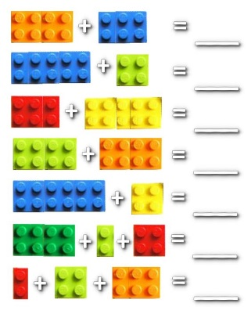  INTERACTIVE  LEGO –  Take 2, 3, 4 etc.  pieces of lego.  Talk about each lego block’s number  (counting circles on top of lego)  and the total number. Repeat.  Find lego blocks to make 10, 20, 50, 100, 150…or challenge your child to make a lego house/monster/animal with blocks that make 50, 100 or more.
SUMDOG | SUMDOG | SUMDOG | SUMDOG
Speak to your child’s teacher if you need a new SUMDOG password.
An example schedule of activities:

Week 1 | Interactive Activity 1 or  ICT Games | Sumdog
Week 2 | Worksheet 1 | Sumdog
Week 3 | Interactive Activity 2 or  ICT Games | Sumdog
Week 4 | Worksheet 2 | Sumdog
