
Early Level (Nursery – P1)
Show double patterns for 1 to 5 (two hands).

Show doubles plus one (two hands e.g. double 3 plus 1).

Combining and Partitioning Numbers
Skills Progression

Start at the highlighted
step.
Recognise straight away (without having to count) flashed patterns:
- the number of dots on dominoes/dice
- the number of random dots or other objects on a flashcard.

Show numbers 1 to 5 using finger/s (one hand).

Partition numbers (e.g. “Make 4 on your fingers. Can you make it another way?”). Two hands.

Early Level (P1) Combining and Partitioning Numbers Online Activities

STUDY LADDER COUNTING AND NUMBERS

https://www.studyladder.co.uk/learn/study-pod/17/counting-and-numbers

Try these games:
- ‘Connecting Number Names to 10’ activities 5, 6, 7.
- ‘Subitising Using Dot Patterns’ activities 1, 2, 3
- ‘Subitising Using Objects’ activities 1, 2, 3, 4

These links are on the school website in the ‘Maths’ folder in the ‘Learning’ tab.
Tick and date each activity you complete. You must complete at least four activities this month as well as Sumdog if possible.
Speak to your child’s teacher if you need a new SUMDOG password.
Connecting Number Names ONLINE Activity | Subitising Using Dot Patterns ONLINE Activity | Subitising Using Objects ONLINE Activity | WORKSHEET 1
WORKSHEET 2   | INTERACTIVE ACITIVTY LEGO TOWER  Roll a dice. Collect the right number of blocks. Repeat. Now build a tower. Extend by asking your child to use the same number of blocks but make a tower/building/monster of a different shape. | INTERACTIVE ACTIVITY  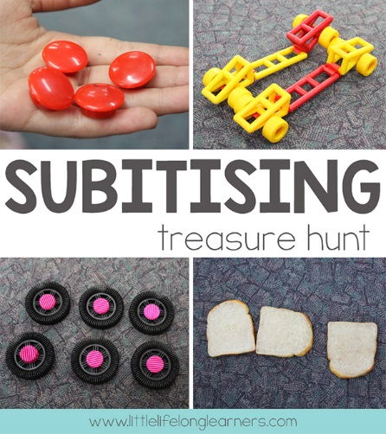  COLLECTION HUNT  Around the house or garden  collect sets of 2, 3, 4, 5 etc.  E.g. 6 toy cars, 8 stones.  Take a photo of each collection.  Talk about how the collection is  made up. Ask your child if they  notice any patterns.
SUMDOG | SUMDOG | SUMDOG | SUMDOG
An example schedule of activities for P1:

Week 1 | Interactive Activity 1 or  Online Activity | Sumdog
Week 2 | Worksheet 1 | Sumdog
Week 3 | Interactive Activity 2 or  Online Activity | Sumdog
Week 4 | Worksheet 2 | Sumdog
