September Newsletter 2017

Dear Families
September was a really busy month; here are some of the exciting things that went on…

Quiz Night
On Friday 22nd, PALS put on the first ever Longstone Quiz Night. It was a fantastic night, well attended by families. Congratulations to the family of Frankie, Lily and Mia Kerr who came first! Thanks to PALS for organising the night and also to Mrs Masson who was an excellent quiz host.

Staffing
I am delighted to share with you that we have appointed Mr Tom Hawkey as class teacher of P6/7. Mr Hawkey will be taking up his post around the start of November and he will be with us, full time, for the rest of the year. In the nursery, we have appointed Mrs Lynda MacDonald to the post of Early Years Practitioner (EYP) part-time. We will also be joined after October by a new full-time EYP, Miss Hazel Muir, as well as a part-time EYP Miss Katie Gilmour.

Outdoor Learning Container Project
At Parents Evening on Thursday, many of you had the chance to see our fantastic new Outdoor Learning container. We can’t thank Miss Reynolds and, volunteer engineer, Ian Bracco enough for all of the hard work they have put into making this fantastic, unique space.

P7 Shakespeare Schools Foundation – Macbeth Performance
Ms Giebeler and P7 have been working their socks off all term on their forthcoming production of Macbeth. As part of this year’s Shakespeare Schools Festival, they will be performing the Shakespeare play on Thursday 9th November at the Churchill Theatre. We can’t wait to see the performance. If you would like to purchase tickets, the Churchill theatre box office details are 0131 228 1155/ www.usherhall.co.uk.
FAST
We will be running the award-winning family-based programme ‘FAST’ (Families and Schools Together) after the October holidays.
The programme is led by Miss McGovern and Mrs Masson and we are delighted to tell you that Mrs Westgarth, our administrator, and Mrs High, one of our Pupil Support Assistants, are also going to be joining the FAST team.
We would love it if you and your family could join us once a week (on Thursdays) after school for this exciting experience and we look forward to welcoming you. If you would like more information, please contact Mrs Westgarth, Miss McGovern or Mrs Masson.

Maths Week Scotland
All of our Longstone pupils, from Nursery to P7, had a fantastic time during Maths Week Scotland. All classes were set the challenges of doing problem-solving every day and of learning Maths in ways that would help develop a Mathematical Mindset. The children were encouraged to be creative, explain their thinking and, most of all, have a positive mindset. On Friday 22nd, at assembly, all classes shared their learning and we were all amazed at the creative thinking that had gone on during Maths Week. Here are some pictures of P6/7’s mind-blowing Mathematical thinking…
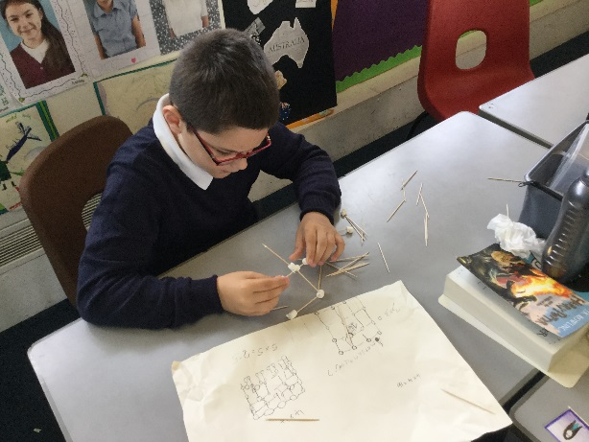
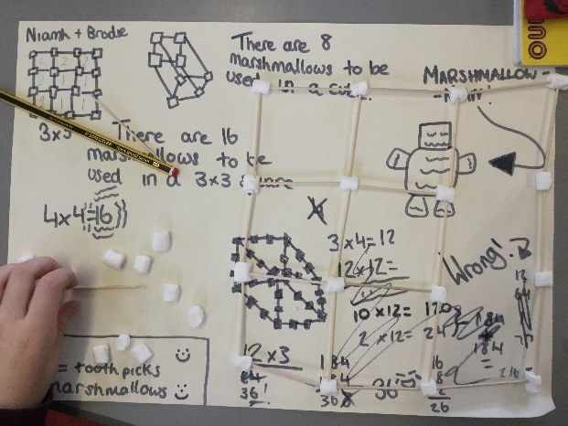

Scots Fiddle Festival
On the morning of November 6th, Eilidh Steel and Mark Neal, top class traditional musicians, will be coming to play for our Longstone pupils. The visit is part of the Scots Fiddle Festival and is designed to promote awareness of Scottish fiddle and traditional music. The visit has been funded by Edinburgh Council and is completely free of charge.

Your Views
Thank you to the many families who took the time at Parents Evening to give us their views on our new Vision, Values and Curriculum Rationale. Our P7 helpers also enjoyed sharing with parents some of the different resources and approaches that we use in Maths including: Big Maths, Sumdog, SEAL (Stages in Early, Arithmetical Learning), Mental Agility and Mathematical Mindsets. There will be an opportunity for families attending parents consultations this Friday to share their views and to find out more about our approaches to teaching and learning in Maths.

Home Learning
Thank you to those parents who have offered to join our Home Learning working group. Letters are being sent home today to those parents with details of our first meeting. If you are interested in getting involved, please contact the school office.
We have had a range of very useful feedback on the new approach to Maths Homework that we have been piloting. Whilst some parents really like the new approach, others have suggested improvements. We will take this on board for the coming month’s booklet which will focus on the Mental Agility strategy of ‘Sequencing and Ordering’.

Harvest

We will be holding our Harvest Assembly on Friday 13th October. On the day, we will be collecting food and other household items to donate to a local foodbank. The foodbank is very low on these items in particular:
- Fruit (tin)  - Cold meat (tin e.g. corned beef)  - Vegetables (tin)  - Pasta Sauce (jar)  - UHT Milk (carton)  - Cereal  - Fruit Juice (long life) | - Custard (tin)  - Potatoes (tin)  - Rice Pudding (tin)  - Toilet Rolls  - Shampoo  - Split Red Lentils  - Vegetable stock cubes  - Jam | - Rice (pack 500g)  - Spaghetti in Sauce (tin)  - Tea Bags (pack of 40s)  - Biscuits  - Tomatoes (tin)  - Soup (tin)  - Fish (tin)  - Sugar

Sponsored Walk Postponed
The Sponsored Walk has been postponed until spring time. We will send out more details nearer the time.
Ticks
As you may have heard already, we have been delighted by the foxes and deer which have been visiting our wonderful woodland. As these animals do often carry ticks, we are sending home some information today with the newsletter on how to check for ticks.

Facebook
Can I ask that if you have a complaint about the school, a pupil or another parent that you contact the school directly rather than posting on Facebook? That way, we can work together to find solutions.

Dates for your Diary
Wednesday October 4th | P7 to Churchill Theatre 10-12pm
Thursday October 12th | P7 STEM event at Edinburgh College (pm)
Friday October 6th | Parents Appointments (afternoon)
Tuesday October 10th | Mr Hawkey to visit P6/7 (afternoon)
Tuesday October 10th | Staff Ipad Training Session (after school)
Monday 16th - Monday 23rd October | Mid-term break
Monday October 23rd | In-Service - school closed to pupils
Tuesday October 24th | Pupils return to school
Thursday November 9th | P7 MacBeth Dress Rehearsal Churchill Theatre 9-12.30pm
Thursday November 9th | P7 MacBeth Performance Churchill Theatre 7-10pm
Tuesday December 12th | P1 Nativity Parents Performance
Friday December 22nd | Last day of term
Monday January 8th | In-Service - school closed to pupils
Tuesday January 9th | Pupils return to school

Yours sincerely,

Angela Pearston
Head Teacher

